DISTRICT 6490 – DISTRICT GRANTS 2017-2018

Changes have been made regarding the processing of District Grants for the 2017-2018 Rotary year.
First of all, Rotary International will only make one payment to a Rotary District for District Grants. This means that the District 6490 District Grants Committee will need to evaluate applications and then send a listing of proposed grants to Rotary International.
Secondly, there are stipulations regarding what grants can be written for as well as what restrictions there are. Go to www.Rotary.org to find detailed stipulations including what isn’t allowed.
Thirdly, the deadline for applying for District Grants will be September 1, 2017. The process to apply is as follows:
- Go to the District 6490 Website to secure an application.
- Complete the entire application.
- ONLY 1 GRANT APPLICATION WILL BE ALLOWED PER CLUB.
- Send the completed application to: pennierotary@comcast.net
- Upon receiving the application, it will be forwarded to the District Grants Committee for their approval (or disapproval).
- If the grant is approved, it will be added to the listing to be sent to Rotary International.
- If the grant is disapproved, reasons will be given.
- If there is money left over, a second round of grants will be accepted.

GUIDELINES FOR DISTRICT GRANTS
- Support local and international projects with a focus on the Mission of the Rotary Foundation.
- Include active participation of Rotarians and publicity.
- Project supports service activities and humanitarian endeavors.
- Club will be responsible for overseeing funding and implementation of the project.
- Club is the primary sponsor of the project, not some other non-Rotary organization.
- None of the funds will be used for salaries, stipends or honorariums.
- None of the funds will be used for travel expenses.
- Any uses of the name “Rotary” or Rotary’s symbols will comply with Rotary International policies.

RESTRICTIONS
- Continuous or excessive support of any one beneficiary, entity or community.
- Cannot establish a foundation, permanent trust or long-term interest-bearing account.
- Cannot purchase land or buildings.
- Cannot fund any fundraising activities.
- Cannot fund expenses related to Rotary events such as district conferences, conventions, institutes, anniversary celebrations, or entertainment activities.
- Cannot fund public relations initiatives, unless they are essential to the project implementation.
- Cannot fund project signage in excess of $500.
- Cannot fund unrestricted cash donations to a beneficiary or cooperating organization.
- Cannot fund activities for which the expense has already been incurred.
- Cannot fund study at a Rotary Peace Center partner university.
- Cannot fund immunizations that consist solely of the polio vaccine.
- Cannot be used to unfairly discriminate against any group; promote a particular political or religious viewpoint; support purely religious functions, support activities that involve abortion or that are undertaken solely for sex determination; fund the purchase of arms or ammunition; or serve as a new contribution to the Foundation or another Rotary Foundation Grant (District or Global).

REPORTING AND STEWARDSHIP
- A Final Report must be submitted within 30 days of the full expenditure of the grant funds.
- Club will submit receipts for all expenditures, will provide competent and proper stewardship of all Grant funds, and will submit an independent financial audit if requested.
DISTRICT GRANT APPLICATION
ROTARY DISTRICT 6490
(MATCHING DISTRICT GRANT or CLUB GRANT)
Rotary Year 2017 – 2018

THE COMPLETED APPLICATION IS DUE NO LATER THAN
SEPTEMBER 1, 2017

_____ MATCHING GRANT PROJECT _____ CLUB GRANT PROJECT
(Club funds matched by District 6490 - (Non-matched grant from District 6490 -
up to $3000) up to $1500 no club funds)

Rotary Club ___________________________________________________

Project Name __________________________________________________

_____ Local project _____ International project

Start Date ______________________ Expected Completion Date _____________________
(must be completed by June 30, 2018)

Name of Primary Club Contact _________________________________________________

E-mail Address ________________________________________________________

Phone _________________________________

Name of Second Club Contact __________________________________________________

E-mail Address ________________________________________________________

Phone ________________________________

- BRIEFLY DESCRIBE THE PROJECT, ITS LOCATION AND OBJECTIVES

- Project Description:

- Location:

c. Objectives:

- Describe how the project will benefit the community and/or improve the lives of the less fortunate.

- Describe the nonfinancial participation by Rotarians in the project. (The number of Rotarians
and how they will be participating in the project including the activities of those participating).

- Describe how the public will know this is a Rotary sponsored project? Please be specific.

- Cooperating Organizations – if the project involves a cooperating organization, please provide the name of the organization below AND attach a letter of participation from that organization that specifically states its responsibilities and how Rotarians will interact with the organization in the project.

Name of Cooperating Organization _______________________________________________

If this is an International Project, identify the district number and cooperating Rotary Club.

District Number and location ________________________________________________

Club Name and Number ____________________________________________________
- Enter Budget Information

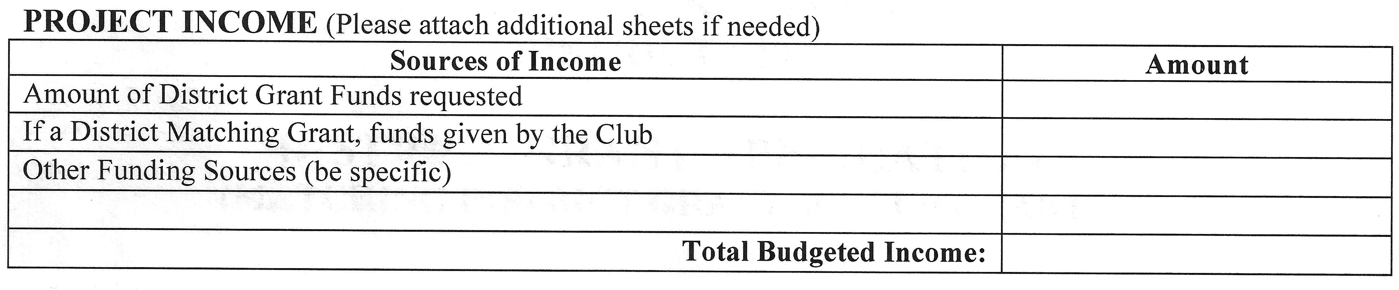
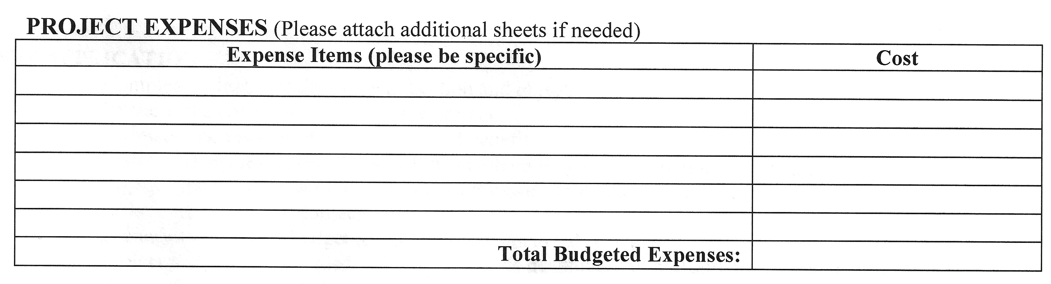

While District 6490 initially requests the budget items outlined above, the District reserves the right to request supporting documentation related to the development of the budget and the Sponsoring Club understands that if requested, it is important for the information to be provided so that the application can be reviewed & processed.

As President and Club Treasurer of the Rotary Club named above, we hereby affirm that the Club’s Board has voted to undertake this project as an activity of the Club. In consideration of receipt of these grant monies, we agree to perform the work necessary to complete this project in the time frame stated and to submit a complete final report within 30 days of the project being completed.

Failure to follow the requirements as outlined in the above identified documents including failure to complete the project or to timely file the Final Report can disqualify the Club from future District Grants and/or necessitate the repayment of the full grant award received.

We affirm that all information in the District Grant Application is true & accurate, to the best of our knowledge.

Grant Year _______________

Club President Club Treasurer
Print name ______________________ Print name ___________________________

Signature ________________________ Signature _____________________________

E-mail ___________________________ E-mail ________________________________

Date _____________________________ Date __________________________________

Send completed application and other required forms to: Larry Pennie
District Grants Chairman
pennierotary@comcast.net
Please put “District Grant” in the heading.

